**Data cleaning, creating new tables, querying**

Please do this part on MySQL or SQL Server or any type of SQL  
-------------------------------------------------------------------------------------  
Please find attached csv files for 3 tables  
  
ims_sales_order_item  
ims_sales_order_item_status  
ims_sales_order_item_status_history  
  
  
ims_sales_order_item - each row in this table represents one item.  
Primary key:  
id_sales_order_item  
Foreign keys:  
fk_sales_order  
fk_sales_order_item_status  
  
ims_sales_order_item_status - this table provides all the possible status that an item can have.  
Primary key:  
id_sales_order_item_status  
Foreign keys:  
fk_oms_function  
  
ims_sales_order_item_status_history - this table provides all the status that each item has gone through. The created_at field provides the timestamp at which the item when through that particular status.  
Primary key:  
id_sales_order_item_status_history  
Foreign keys:  
fk_sales_order_item  
fk_sales_order_item_status  
  
Foreign key - Primary key relationships are as below:  
fk_sales_order_item_status from ims_sales_order_item is linked to id_sales_order_item_status from ims_sales_order_item_status  
fk_sales_order_item_status from ims_sales_order_item_status_history is linked to id_sales_order_item_status from ims_sales_order_item_status  
fk_sales_order_item from ims_sales_order_item_status_history is linked to id_sales_order_item from ims_sales_order_item  
  
  
Question 1. Write a SQL query to display the unit_price, name, SKU, shipping_type of items with id_sales_order_item = 229884  
  
Question 2. Write a SQL query to display the id_sales_order_item, name, SKU, sales_order_item_status for all the items with shipping_type = warehouse and status = delivered  
  
Question 3. Write a SQL query to display the total unit_price of all items which have shipping_type = cross_docking  
  
Question 4. Write a SQL query to display the id_sales_order_item, name, SKU for all the items that went to status = picklisted on anytime during the day on 11/6/2013  
  
Question 5. Write a SQL query to display the total count of items for each of the 3 shipping types - marketplace, cross_docking, warehouse. The count should include only items which have a unit_price between 50 and 100, and also went to status = picklisted on anytime during the day on 11/6/2013  
  
Question 6. Write a SQL query to display the fk_sales_order, id_sales_order_item, name, SKU, sales_order_item_status for all the items which have status before last status  
  
(example for question 6: Item 1 have status a,b,c,d,e,f,g. The last status of the item 1 is g and the status before last status is f )

***Hệ CSDL: Hive SQL***

***Giao diện tương tác: DBeaver***

***Phương án đã thực hiện:***

* ***Create table từ các file csv lên 1 folder được quy hoạch trên DB***
* ***Query từ bảng đã tạo***

**Question 1:**

**select** id_sales_order_item,

unit_price,

name,

sku,

shipping_type

**from** tmp_hanhpn7_sales_order_item_3

**where** id_sales_order_item = 229884

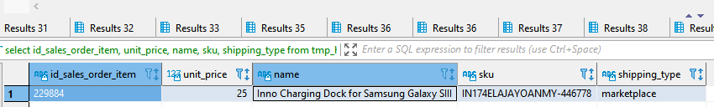

**Question 2:**

**select** a.*, b.status

**from**

(**select** id_sales_order_item,

name,

SKU,

fk_sales_order_item_status,

shipping_type

**from**

tmp_hanhpn7_sales_order_item_3) a

**left** **join**

(**select** id_sales_order_item_status, status

**from** tmp_hanhpn7_sales_order_item_status_3) b

**on** a.fk_sales_order_item_status = b.id_sales_order_item_status

**where** a.shipping_type = 'warehouse' **and** b.status = 'delivered'

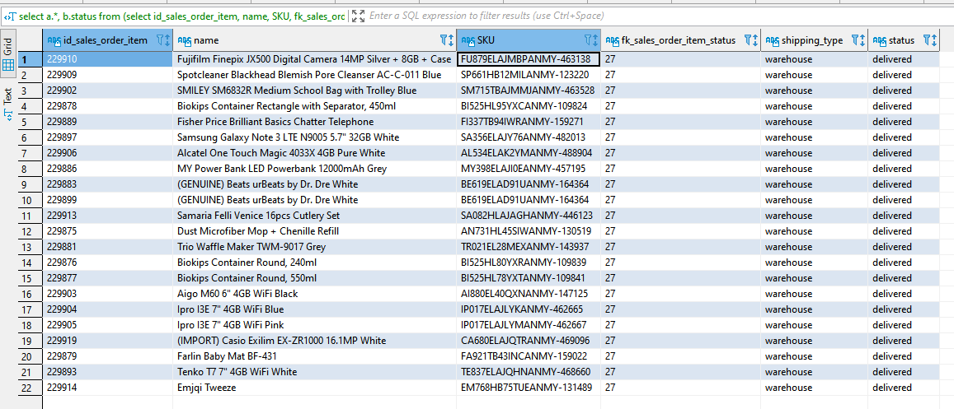

**Question 3:**

**select** shipping_type,

**sum**(unit_price) **as** total_unit_price

**from** tmp_hanhpn7_sales_order_item_3

**where** shipping_type = 'cross_docking'

**group** **by** 1;

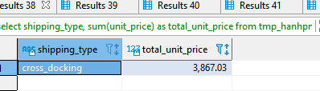

**select** id_sales_order_item,

**sum**(unit_price) **as** total_unit_price

**from** tmp_hanhpn7_sales_order_item_3

**where** shipping_type = 'cross_docking'

**group** **by** 1;

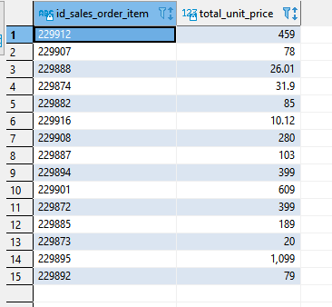

**Question 4:**

**select** item_info.id_sales_order_item,

item_info.name,

item_info.SKU,

item_list.id_sales_order_item_status,

item_list.status,

item_list.updated_at

**from**

(**select** b.fk_sales_order_item,

a.id_sales_order_item_status,

a.status,

a.updated_at

**from**

(**select** id_sales_order_item_status, status, updated_at

**from** tmp_hanhpn7_sales_order_item_status_3

**where** status = 'picklisted' **and** updated_at = 20131106) a

**left** **join**

(**select** fk_sales_order_item,

fk_sales_order_item_status

**from** tmp_hanhpn7_sales_order_item_history_3) b

**on** a.id_sales_order_item_status = b.fk_sales_order_item_status) item_list

**left** **join**

(**select**

id_sales_order_item,

name,

SKU

**from** tmp_hanhpn7_sales_order_item_3) item_info

**on** item_list.fk_sales_order_item = item_info.id_sales_order_item

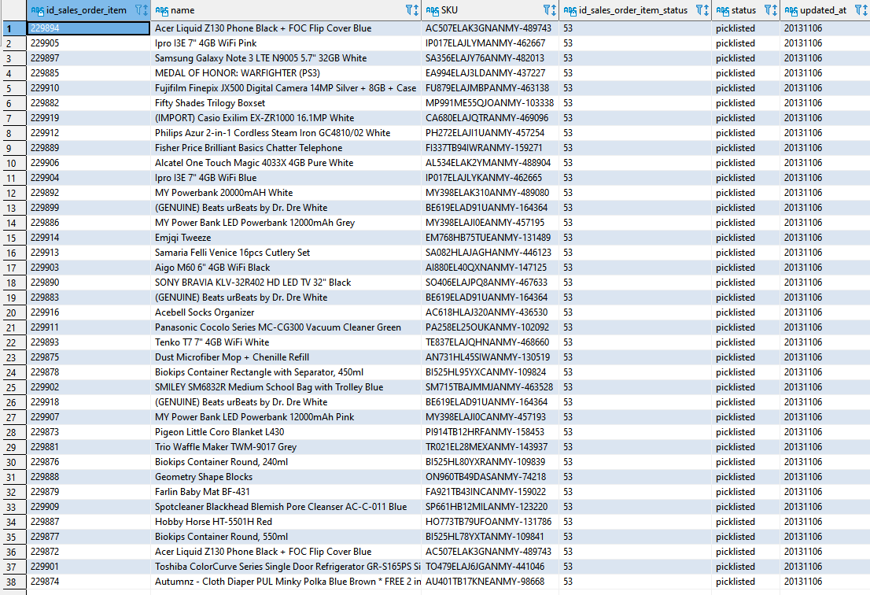

**Question 5:**

**select** **count** (picklisted_item.fk_sales_order_item),

**count** (**distinct** picklisted_item.fk_sales_order_item)

**from**

(**select** b.fk_sales_order_item,

a.id_sales_order_item_status

**from**

(**select** id_sales_order_item_status

**from** tmp_hanhpn7_sales_order_item_status_3

**where** status = 'picklisted' **and** updated_at = 20131106) a

**left** **join**

(**select** fk_sales_order_item,

fk_sales_order_item_status

**from** tmp_hanhpn7_sales_order_item_history_3) b

**on** a.id_sales_order_item_status = b.fk_sales_order_item_status) picklisted_item

**left** **join**

(**select**

id_sales_order_item,

unit_price

**from** tmp_hanhpn7_sales_order_item_3

**where** unit_price >= 50 **and** unit_price <= 100) price_item

**on** picklisted_item.fk_sales_order_item = price_item.id_sales_order_item

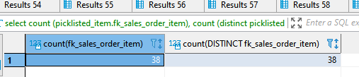

**Question 6**

----list of items which have status before last status

**select** all_item_list.fk_sales_order_item,

all_item_list.fk_sales_order_item_status,

last_status_list.id_last_status

**from**

(**select**

fk_sales_order_item,

fk_sales_order_item_status

**from** tmp_hanhpn7_sales_order_item_history_3) all_item_list

**left** **join**

(**select**

fk_sales_order_item,

**max**(fk_sales_order_item_status) **as** id_last_status

**from** tmp_hanhpn7_sales_order_item_history_4

**group** **by** fk_sales_order_item) **as** last_status_list

**on** all_item_list.fk_sales_order_item = last_status_list.fk_sales_order_item

**where** all_item_list.fk_sales_order_item_status < last_status_list.id_last_status

---display fk_sales_order, id_sales_order_item, name, SKU, sales_order_item_status

**select** b.id_sales_order_item,

b.fk_sales_order,

b.name,

b.SKU,

a.fk_sales_order_item_status

**from**

(**select** all_item_list.fk_sales_order_item,

all_item_list.fk_sales_order_item_status,

last_status_list.last_status

**from**

(**select**

fk_sales_order_item,

fk_sales_order_item_status

**from** tmp_hanhpn7_sales_order_item_history_4) all_item_list

**left** **join**

(**select**

fk_sales_order_item,

**max**(fk_sales_order_item_status) **as** last_status

**from** tmp_hanhpn7_sales_order_item_history_3

**group** **by** fk_sales_order_item) **as** last_status_list

**on** all_item_list.fk_sales_order_item = last_status_list.fk_sales_order_item

**where** all_item_list.fk_sales_order_item_status < last_status_list.last_status) a

**left** **join**

(**select** fk_sales_order, id_sales_order_item, name, SKU

**from** tmp_hanhpn7_sales_order_item_3) b

**on** a.fk_sales_order_item = b.id_sales_order_item

